EARTH AND SPACE
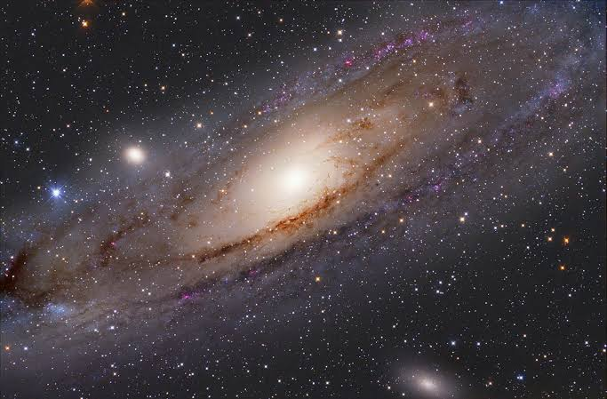

Year 10 Earth and Space Unit 1

The universe contains features including galaxies, stars and solar systems, and the Big Bang theory can be used to explain the origin of the universe (ACSSU188)

Week | Topic | Outcomes | Resources | Assessment (plus weighting)
1 | Introduction to the universe | - Students to review prior learning  - Size of the universe and scale  - Measuring distance in space  - Parallax and how to use it measure distances in space  - Light years as a measure of distance  - Calculating light speed | Stile app  Education Perfect  Universe intro video  Scale app  MIcrowave and chocolate melting
2 | Big Bang Theory | - Introduction to the Big Bang Theory  - Evidence supporting the Big Bang  - Rapid expansion Theory  - Scientists and theories supporting the Big Bang | Google classroom  Big Bang Rubric  Stile app | Big Bang Theory report (7.5%)
3 | Life cycle of Stars | - stellar life cycles (small and large stars)  - Planet formation from the remains of exploded stars  - Classification of galaxies  - Evidence for the Big Bang  - Hubbles Law, redshift, Doppler effect | Stile app  https://www.twig-world.com/film/what-are-stars-913/  Netflix - the origins of the universe.
4 | Observing the night sky | - Use of technology to observe universe  - Radio telescopes, satellites etc.and how they are used to record the observable universe  - Magnitude of brightness to determine the size of stars  - EM spectrum and satellites
5 | Neutron stars and black holes  Review and consolidate | - death of stars and what they become  - Black holes, gravity and gravitational waves | Bookcreator revision resource | Topic test (5%)  Glossary  Semester 1 exam  (20%)

Year 10 Earth and Space Unit 2

Global systems, including the carbon cycle, rely on interactions involving the biosphere, lithosphere, hydrosphere and atmosphere (ACSSU189)

Week | Topic | Outcomes | Resources | Assessment (plus weighting)
1 | Global Systems | - Looking at the different closed system cycles on earth - carbon, nitrogen and water cycles | - stile app  - Twig video
2 | Global Systems | - examples of how the carbon, nitrogen and water cycles work in closed systems, how biotic and abiotic factors affect each cycle.  - (phosphorus cycle) | - Keynote
3 | Climate history and change | - What is the greenhouse effect?  - The positive and negatives of a greenhouse effect  - Climate change and sea levels/biodiversity. How is the climate changing and how does human activity affect it  - Temperature change over time. | - www | - research report on Human influenced climate change (7.5%)
4 | Human effects on earth systems | - climate change - the effects of climate change (Australian droughts, floods, hurricanes etc)  - Permafrost and ice loss in the Tundra and polar regions of earth  - Habitat loss as a cause of climate change
5 | Biodiversity | - loss of biodiversity and its effects on ecosystems  - Habitat loss |  | - topic test (5%)  - Semester 2 exam (20%)

